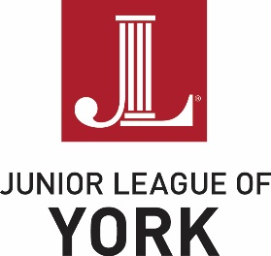
SCHOLARSHIP APPLICATION
Application Deadline: March 1, 2026

Applicant’s Name: Phone:
Address:
Email:
Current High School Grade/Post Secondary Year:
High School Name:
Guidance Counselor/Academic Advisor:
Post Secondary Educational Institution Applied/Enrolled:
Intended/Committed Major:
Intended Career:
Through my signature below:
- I certify that all information contained in this scholarship application is accurate,
- I give consent for the Junior League of York to contact any individuals listed in this scholarship application,
- I give permission for the Junior League of York to publish my name, information, and photo if I am a scholarship recipient,
- I agree to attend the Junior League of York’s Membership Meeting on Tuesday, May 5, 2026, at 6:00 pm, to accept the scholarship award, if selected as the scholarship recipient,
- I affirm that I am not an immediate family member of a current member of Junior League of York.

Applicant’s Signature:

List agencies where you completed your most significant volunteer work
If needed, more rows may be added to the chart.
Agency/  Contact Person | Assignment | Volunteer  Experience  Timeline  (Month/Year) | Total Hours | Did you serve in a leadership role? | Was this experience used to fulfill school required volunteer hours?

List your extracurricular activities both in and out of school
If needed, more rows may be added to the chart.
Extracurricular Activity | Positions Held  (Participant, Member, Officer, Etc.) | Timeline  (Month/Year) | Was this experience school or community related?

In 500 words or less, share your most rewarding volunteer experience and explain how the experience was impactful to you and the community.

